Individually optimal parameters for RandomForestRegressor:

* RandomForestRegressor calibrated 1 – so far the best (0.557 on test). XGBoost calibrated 2 – 0.54 on test data)
* Number of trees – 70 => 0.55 R^2. Latest => 700
* Criterion – mse
* Max_features – auto
* Tree_depth – no limit. Latest => 30
* Min_samples_leaf = 2. Latest => 3
* Max_leaves_nodes -> max
* bootstrap => definately True (default)
* verbose => 0

overall, default model (with no parameters calibrated) gives 0.52 on test data. The calibrated model (where number of trees = 70 and min_samples_leaf = 2 gives 0.63. On another try the improvement was much more modest – from 0.555 to 0.568

Individually optimal parameters for XGBoost:

* max_depth=5 from grid search. 7 from manual (or 4 if more conservative) – check with test data! Range =
* Min_child_weight = 9 from grid search. 7 from simple loop. Range – [1-11].
* Gamma = 1. Range = [0 – 20]. n/s. Can try 0
* subsample = 0.8 by grid search. 0.7 by loop. Range – [0.5-1]
* colsample_bytree = 0.7 by grid search. 0.8 by loop. range = [0.6-1]
* colsample_bylevel = 1 for grid search. 0.65 by loop. range = [0.3 – 1]
* 'reg_alpha': 0.01. range=[0 – 0.015]
* Reg_lambda = 1
* Scale_pos_weight = 1 range=[0-1000]
* Learning_rate = 0.14 by grid search; 0.18 by loop. Range = [0.10 – 0.30]. 0.1 for final
* n_estimators = 175 with grid search; 199 by loop. Range = 150-220
* {'learning_rate': 0.075, 'n_estimators': 275},
* n_trhead = 4. Affects only speed. On my laptop 8 would be better, but for should be fine.
* Max_delta_step=0. Range – [0 – 100]
* model = XGBRegressor(max_depth=5, min_child_weight=9, n_estimators=275,
* subsample=0.8, colsample_bytree=0.7, colsample_bylevel=1,
* gamma=1, reg_alpha=0.01, reg_lambda=1, learning_rate=0.075, nthread=8)
* With court_dummies and randoms seeds = 1

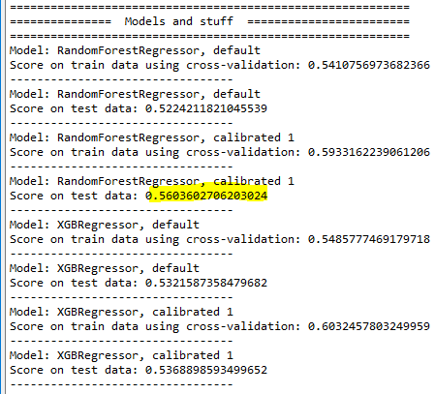

* Without court_dummies and randoms seeds = 1

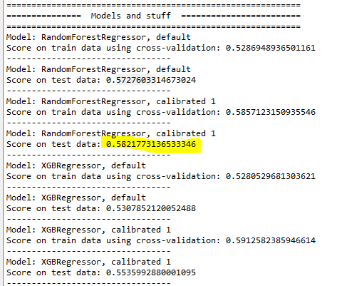

* With court_dummies and randoms seeds = 2

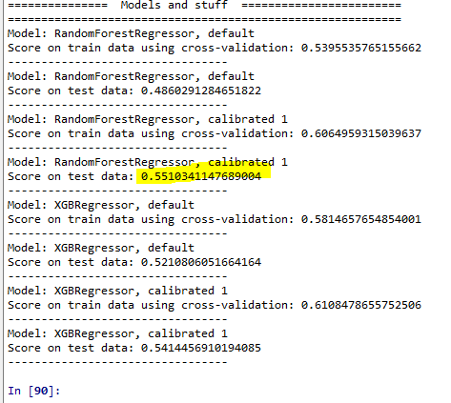

* Without court_dummies and randoms seeds = 2

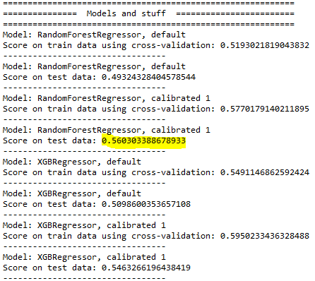

Best model with MSE as a scoring method

(with start_date_float, but without month_float_start_date and month_int_start_date)

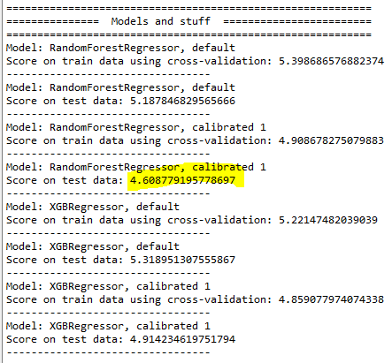

Exclude

keep

'start_date_day'

'start_date_month'

('start_date_month_float'

'start_date_float'

'start_date_quarter'

'start_date_year'

'court_name'

'court_id'

'duration_m',

'region',

# 'reciept_procedure_case_join',

# 'reciept_procedure_case_split',

# 'reciept_procedure_court_belonging',

# 'reciept_procedure_first',

# 'reciept_procedure_quick',

# 'reciept_procedure_ruling_cancel',

# 'money_amount_req_less_2',

# 'money_amount_req_zero',

# 'p_to_p_dummy',

# 'p_to_b_dummy',

# 'b_to_b_dummy',

# 'b_to_p_dummy',

# 'b_and_p_other_dummy',

# 'case_matter_contract_breach',

# 'case_matter_insurance',

# 'case_matter_loan_recovery',

# 'case_matter_loss_recovery',

# 'case_matter_money_recovery',

# 'case_matter_other',

# 'case_matter_pay_recovery',

# 'case_matter_property',

# 'case_matter_rent',

# 'case_matter_support',

# 'court_aizkraukles_rajona_tiesa',

# 'court_alūksnes_rajona_tiesa',

# 'court_bauskas_rajona_tiesa',

# 'court_cēsu_rajona_tiesa',

# 'court_daugavpils_tiesa',

# 'court_dobeles_rajona_tiesa',

# 'court_gulbenes_rajona_tiesa',

# 'court_jelgavas_tiesa',

# 'court_jēkabpils_rajona_tiesa',

# 'court_kuldīgas_rajona_tiesa',

# 'court_kurzemes_rajona_tiesa',

# 'court_liepājas_tiesa',

# 'court_limbažu_rajona_tiesa',

# 'court_madonas_rajona_tiesa',

# 'court_ogres_rajona_tiesa',

# 'court_rēzeknes_tiesa',

# 'court_rīgas_pilsētas_kurzemes_rajona_tiesa',

# 'court_rīgas_pilsētas_latgales_priekšpilsētas_tiesa',

# 'court_rīgas_pilsētas_pārdaugavas_tiesa',

# 'court_rīgas_pilsētas_vidzemes_priekšpilsētas_tiesa',

# 'court_rīgas_pilsētas_zemgales_priekšpilsētas_tiesa',

# 'court_rīgas_pilsētas_ziemeļu_rajona_tiesa',

# 'court_rīgas_rajona_tiesa',

# 'court_rīgas_rajona_tiesa_jūrmalas_tiesu_nams',

# 'court_saldus_rajona_tiesa',

# 'court_talsu_rajona_tiesa',

# 'court_tukuma_rajona_tiesa',

# 'court_valkas_rajona_tiesa',

# 'court_valmieras_rajona_tiesa',

# 'court_ventspils_tiesa',

'loadiness_of_court',

# 'not_subject_to_duty_not_zero',

# 'persons_and_compnies_answering',

# 'lives_abroad_over_persons_and_companies_answering',

# 'start_date_month',

# 'start_date_quarter',

# 'persons_and_compnies_started',

# 'single_person_or_company_started',

# 'single_person_or_company_answered',

# 'court_judge_count',

# 'court_productivity',

# 'money_amount_requested',

# 'person_answering_to_case',

# 'legal_entity_answering_to_case',

# 'person_started_the_case',

# 'legal_entity_started_the_case',

# 'court_meetings_set', --------------- affects some 20%

# 'court_meetings_happened',

# 'admin_penalty', < - fix or kick out

‘admin_penalty_not_zero’

# 'lives_abroad',

# 'not_subject_to_duty',

'money_amount_from_2_to_15',

'money_amount_from_15_to_50',

'money_amount_from_50_to_500',

'money_amount_from_500_to_1000',

'money_amount_from_1000_to_2000',

'money_amount_from_2000_to_5000',

'money_amount_from_5000_to_50_000',

'money_amount_from_50_000_to_1000_000',

'money_amount_over_1000_000',

# 'court_meetings_set_is_zero',

# 'court_meetings_happened_is_zero',

Best without time variables:

